Exceptions

Model Answers

1. **What is an exception?**

An exception is the stopping of normal program flow and continuing at some surrounding code block.

1. **What does the acronym LBYL stand for?**

Look Before You Leap

1. **What is an exception handler?**

Any code block that executes when an exception is thrown.

1. **Explain how the code below follows the approach Easier to Ask Forgiveness than Permission.**

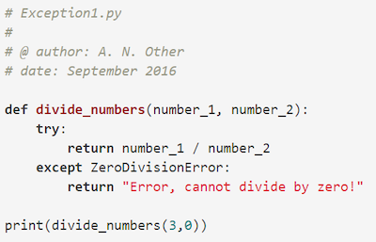

The code shown uses a try statement to perform the operation that might throw an exception